**KETAN VENKATESH PILLAI**

**Module (Bootstrap Basic & Advanced) – 6**

1. **What are the advantages of Bootstrap?**

**Ans :-** Bootstrap, a popular front-end framework, offers several advantages for web development:

1. **Responsive Design:** Bootstrap is built with a mobile-first approach, providing a responsive grid system and components that automatically adjust to different screen sizes. This ensures a consistent and optimized user experience across various devices.

2. **Time Efficiency:** Bootstrap comes with a set of per-designed and customization components (such as buttons, forms, navigation bars) and a responsive grid system. This allows developers to save time by using ready-made elements and focusing on customization rather than starting from scratch.

3**. Consistent Design:** Bootstrap helps maintain a consistent design throughout a project. The framework provides a unified set of styles and components, promoting a cohesive and professional appearance across the entire website or application.

4. **Cross-browser Compatibility:** Bootstrap is designed to be compatible with popular web browsers, ensuring that your website or application looks and functions consistently across different browsers.

5. **Community Support:** Bootstrap has a large and active community of developers. This means there are plenty of resources, documentation, and third-party plugins available, making it easier for developers to find solutions to common issues or get help when needed.

6. **Flexibility and Customization:** While Bootstrap provides a solid foundation with default styles and components, it is highly customizable. Developers can easily modify the framework's appearance and behaviour to suit the specific needs and branding of a project.

7. **Extensive Documentation:** Bootstrap comes with comprehensive documentation that includes examples, explanations, and guidelines. This documentation makes it easier for developers to learn and implement Bootstrap effectively.

8. **Built-in JavaScript Plugins:** Bootstrap includes a variety of JavaScript plugins, such as carousels, modals, and tooltips, which can be easily integrated into your project. This saves development time and ensures consistent functionality.

9. **Open Source:** Bootstrap is an open-source framework, meaning it is free to use, and developers can contribute to its improvement. This open nature encourages collaboration and innovation within the development community.

10. **CSS Pre-processing Support:** Bootstrap is compatible with popular CSS pre-processors like Sass and Less, allowing developers to use advanced features such as variables, nesting, and mix ins for more efficient and maintainable stylesheets.

1. **What is a Bootstrap Container, and how does it work?**

Ans:- Bootstrap provides two main types of containers:

1. container
2. container-fluid
3. **container:** The .container class creates a fixed-width container, meaning it has a specific width regardless of the screen size.

It is centered on the page and has a responsive layout, adjusting its width based on the screen size to maintain a consistent appearance.

The fixed width is defined using media queries for different breakpoints, ensuring a well-proportioned layout on various devices.

Example:

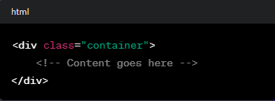

1. **container-fluid:**

The .container-fluid class creates a full-width container that spans the entire width of the viewport.

It is responsive and adjusts its width based on the screen size, providing a fluid layout.

This type of container is often used for full-width background sections or elements.

Example

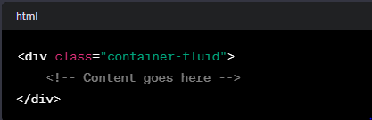

1. **What are the default Bootstrap text settings?**

Ans:-

1**. Text Alignment:**

- text-left : Aligns text to the left.

- text-center: Centers text.

- text-right: Aligns text to the right.

- text-justify: Justifies text.

Example:

<p class="text-left">Left-aligned text.</p>

<p class="text-center">Centered text.</p>

<p class="text-right">Right-aligned text.</p>

<p class="text-justify">Justified text.</p>

**2. Text Transformation:**

- text-uppercase: Transforms text to uppercase.

- text-lowercase: Transforms text to lowercase.

- text-capitalize: Capitalizes the first letter of each word.

Example:

<p class="text-uppercase">uppercase text</p>

<p class="text-lowercase">LOWERCASE TEXT</p>

<p class="text-capitalize">capitalize each word</p>

**3. Font Weight:**

- font-weight-bold: Sets the font weight to bold.

- font-weight-normal: Sets the font weight to normal.

Example:

<p class="font-weight-bold">Bold text.</p>

<p class="font-weight-normal">Normal weight text.</p>

1. **What do you know about the Bootstrap Grid System?**

Ans:- The Bootstrap Grid System is a responsive, mobile-first grid system that facilitates the creation of complex layouts with a consistent and flexible structure. It is a key component of the Bootstrap front-end framework and is based on a 12-column layout.

**Rows**:

Inside the container, rows are created using the <div class="row"> element. Rows act as horizontal containers for columns.

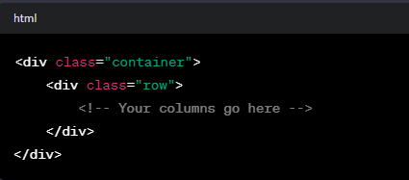

**Columns**:

Columns are placed inside rows and are defined using classes such as .col-sm, .col-md, and so on. The number after "col-" represents the number of columns the element should span out of the total 12 columns available in the grid.

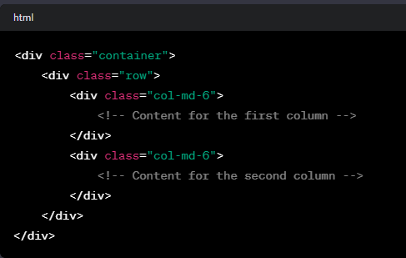

**Responsive** **Classes**:

Bootstrap provides responsive classes to control the layout at different breakpoints. For example, .col-sm-6 will make the column take 6 out of 12 columns on small screens and larger.

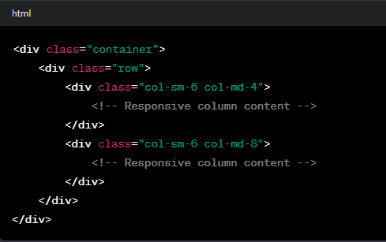

1. **What is the difference between Bootstrap 4 and Bootstrap 5**

Ans:-

**1. JavaScript Framework:**

- Bootstrap 4: Used jQuery as a JavaScript dependency for some of its components.

- Bootstrap 5: Removed the jQuery dependency, aiming for a more lightweight and modern approach. Bootstrap 5 encourages the use of native JavaScript for interactions and functionality.

**2. Utility Classes:**

- Bootstrap 4: Primarily relied on classes for styling and layout, with a large number of utility classes.

- Bootstrap 5: Maintains utility classes but has streamlined and optimized them. Some classes have been renamed for consistency.

**3. Customization and Theming:**

- Bootstrap 4: Utilized Sass variables for theming and customization.

- Bootstrap 5: Extends theming capabilities by introducing a new Sass-based system that makes it easier to customize colors, spacing, and more.

**4. Dropped Features:**

- Bootstrap 5: Removed some components and features that were present in Bootstrap 4. For example, the card deck and card group components were combined into a single card component.

**5. New Components:**

- Bootstrap 5: Introduces new components, such as the accordion, off-canvas navigation, and improved form controls.

**6. Grid System Enhancements:**

- Bootstrap 5: Retains the 12-column grid system but introduces improvements, including vertical spacing classes, improved grid container, and easier customization.

**7. Icons:**

- Bootstrap 4: Required a separate library (Font Awesome, for example) for icons.

- Bootstrap 5: Includes its own set of icons called "Bootstrap Icons," making it more self-contained.

**6) What is a Button Group, and what is the class for a basic Button Group?**

Ans:- A Button Group in Bootstrap is a group of buttons that are visually connected to each other. It's a useful component for organizing and presenting related buttons together

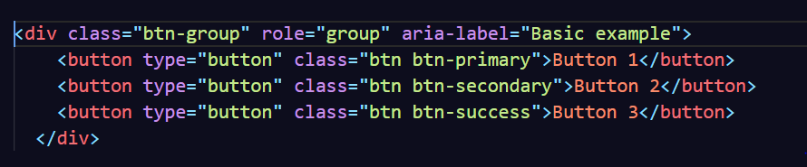

**7) How can you use Bootstrap to make thumbnails?**

Ans:- In Bootstrap, thumbnails are used to display images or other content in a grid-like layout, providing a visually appealing way to showcase multiple items. 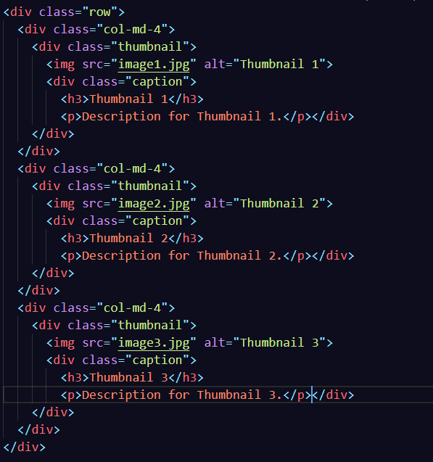

**8) In Bootstrap 4, what is flexbox?**

Ans:- Here are some key aspects of Flexbox in Bootstrap 4:

1. **Container and Items:** The container in which you apply the Flexbox properties becomes a flex container, and its children become flex items. In Bootstrap 4, you can enable Flexbox by using the .d-flex class on a container element.
2. **Direction:** The direction of the flex container can be set using classes like .flex-row, .flex-column, .flex-row-reverse, and .flex-column-reverse to define the direction as row, column, reverse row, or reverse column, respectively.
3. **Justify Content:** The .justify-content classes can be used to control the alignment of flex items along the main axis (horizontal axis for row direction, vertical axis for column direction).
4. **Align Items and Align Self:** The .align-items class sets the alignment of flex items along the cross-axis. The .align-self class can be applied to individual flex items to override the alignment set by the container.
5. **Flex Wrap:** The .flex-wrap class can be used to enable wrapping of flex items onto multiple lines if they don't fit on one line.
6. **Responsive Flex Utilities:** Bootstrap 4 provides responsive utility classes that can be used to apply Flexbox properties at specific breakpoints.

**10) How can one create an alert in Bootstrap?**

Ans:- In Bootstrap, you can create alert messages using the .alert class along with contextual classes for different alert styles (e.g., success, info, warning, danger). Alerts are used to provide feedback or notify users about certain actions or conditions.

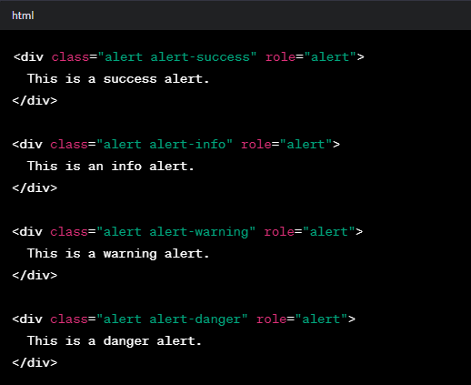

**11) What is a bootstrap card and how would you create one?**

Ans:-

A Bootstrap card is a container component provided by the Bootstrap framework that is used to organize and display content. It's a versatile element commonly used to present information in a structured and visually appealing way. Cards in Bootstrap can be used for various purposes, such as displaying images, text, links, buttons, and more.

**Example**

**Please Find attached file (source code and output)**